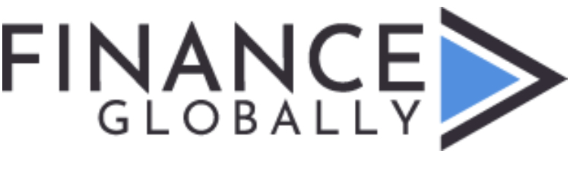

Gold & Diamond Referral of Seller to Buyer (Via: Phoenix Rising)

SELLER COMPANY NAME

Address:
contact name:
contact phone/email:

TOTAL GOLD/DIAMONDS Available IMMEDIATELY (kg or carats):

Amount Available Weekly/Monthly (“NONE” if SPOT only):
Seller Price as SOFT Quote:

GOLD:
Discount from LBMA?
Trial Purchase Available?
22+ carat gold dore bars?
92+ purity?
GOLD MONTHLY Capacity after trial (500kg minimum)?

Buyer to provide BCL/SBLC/BG to Refinery
Payment bank-to-bank after assay
KYC & all documents/registrations will be exchanged
Long term CIF/FOB arrangements & discount to be determined

DIAMONDS (provide description or list)

- Finance Globally will match potential Sellers & Buyers. Then both parties finalize additional terms & procedures directly.
- Mutual due diligence expected. All parties hold Finance Globally harmless for results.
- Seller confirms industry standard commission to Finance Globally for all future downstream transactions with referred Buyers – to be paid by Seller (or offset by Seller price discount if Buyer agrees to pay). NCNDA/IMFPA will apply as required.
- Seller accepts USD 2400/kg Gold Commission or 8% plus USD 400 per carat Diamond Commission to Finance Globally/Buyer Side.

SIGN & SEAL

(signed) NAME/TITLE as AUTHORIZED for the BUYER

